**NANDINI KUMARI**

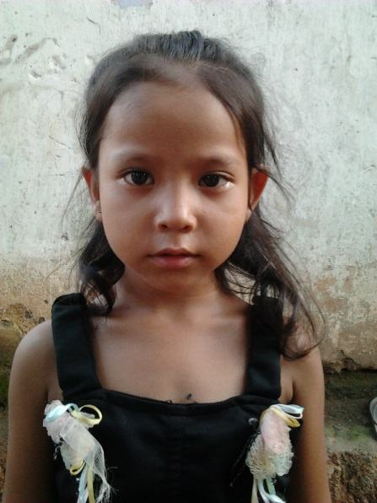

**PERSONAL DETAILS:**

* Class: UKG
* Gender: Female
* School: Gayatri Shiksha Niketan,

Adityapur

* Board of School: CBSE
* Medium of instruction: Hindi

**DETAILS ABOUT FAMILY:**

* Father’s name: Ram Bahadur
* Mother’s name: Meena Devi
* No of members in family: Four, one brother, mother and father
* Profession of father:
* Profession of mother: Housewife

**FINANCIAL OVERVIEW:**

Monthly net income of household: Rs. 1000/-

**Total annual expenditure on education: Rs. 11,700/-**

Breakup of expenses

Tuition fees: Rs 250/- (per month) = Rs. 3000/- (per year)

Admission fees: Rs. 1500/- (per year)

Bus fees: Rs. 350/-(per month) = Rs. 4200/- (per year)

Stationery: Rs. 3000/- (per year)

**Average monthly expenditure on education: Rs. 975/-**

**ENCLOSURES:**

1) Report Card of Class- LKG (Previous class attended)

Report Card Page-1

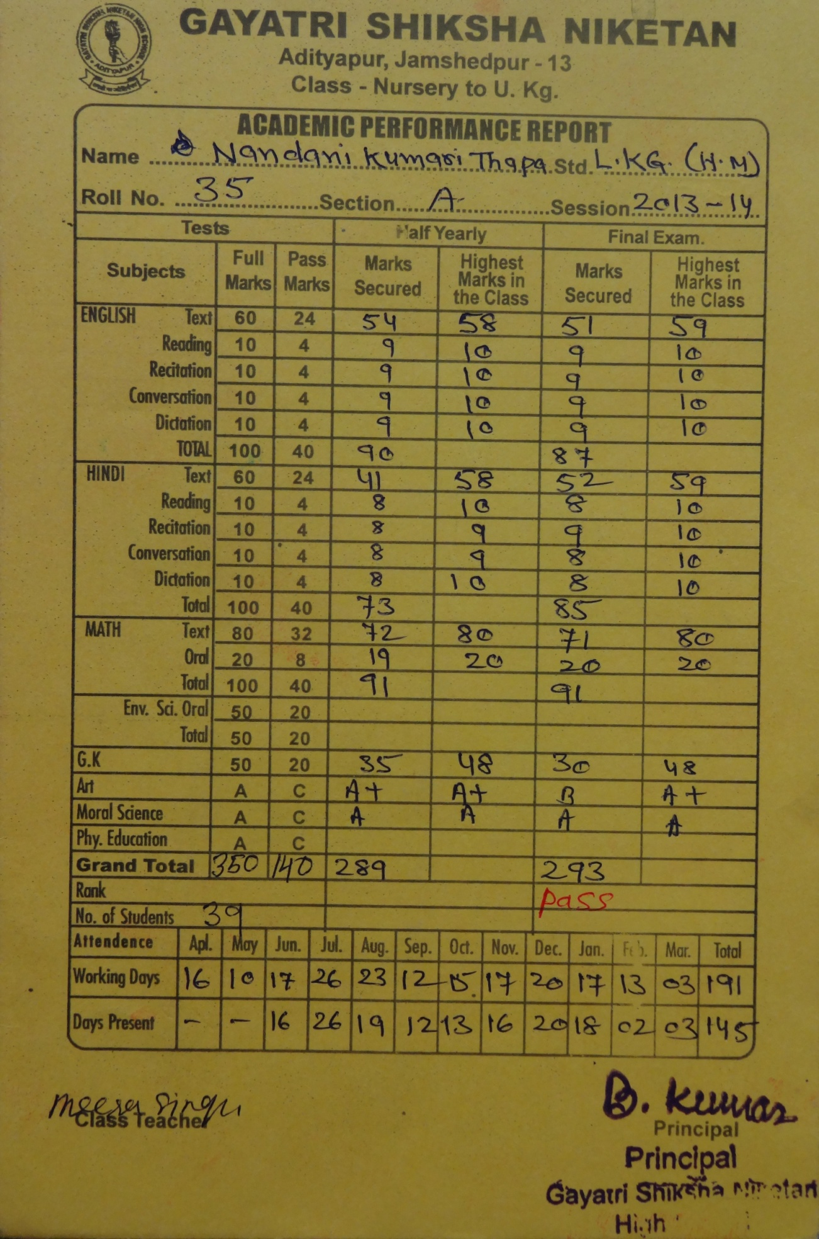

Report Card Page-2

